Final Project: Fair Housing in Northeast Ohio
Northeast Ohio faces many barriers to fair housing. With a significant history of redlining, Cleveland remains an extremely segregated city regarding both race and income (Community Solutions Team, 2022). Multiple programs exist to promote access to affordable housing for disadvantaged populations from the Department of Housing and Urban Development (HUD) such as the low-income housing tax credit program (LIHTC) and the housing choice voucher (HCV) program. The LITHC program distributes over ten billion dollars annually as tax credits for the “acquisition, rehabilitation, or new construction of rental housing targeted to lower-income households” (HUD, n.d.). The HCV program, also known as section eight, allows renters to have a portion of their rent paid directly to the housing provider through a subsidy (HUD, n.d.). These programs are extremely helpful, but in a segregated area such as Cleveland are these programs contributing to concentrated disadvantaged areas or are they promoting upward socioeconomic movement?
To answer this question at the census tract level I first acquired census data and created groups of poverty and income to make conclusions from the data. Then I created two functions to find the spatial distribution of LIHTC properties and HCV usage for any county of interest. This required spatially joining the HUD and census data to acquire the amount of LIHTC properties or HCVs used per tract. This then allowed me to create tables of the count and proportion of the HUD program by poverty and percentage non-white county wide. Additionally, I created choropleth maps of poverty and percentage non-white, and bubble maps of HCV/LIHTC counts by tract. These maps would primarily help viewers see where the concentration of the HUD programs are and compare it to the income and race, while the tables can be used to make wider conclusions of where the programs are being used/placed across the county.
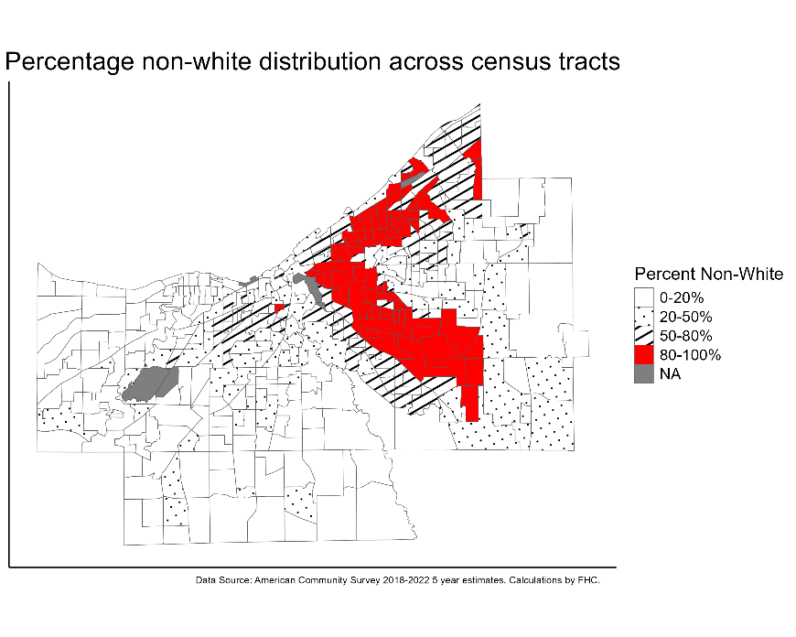
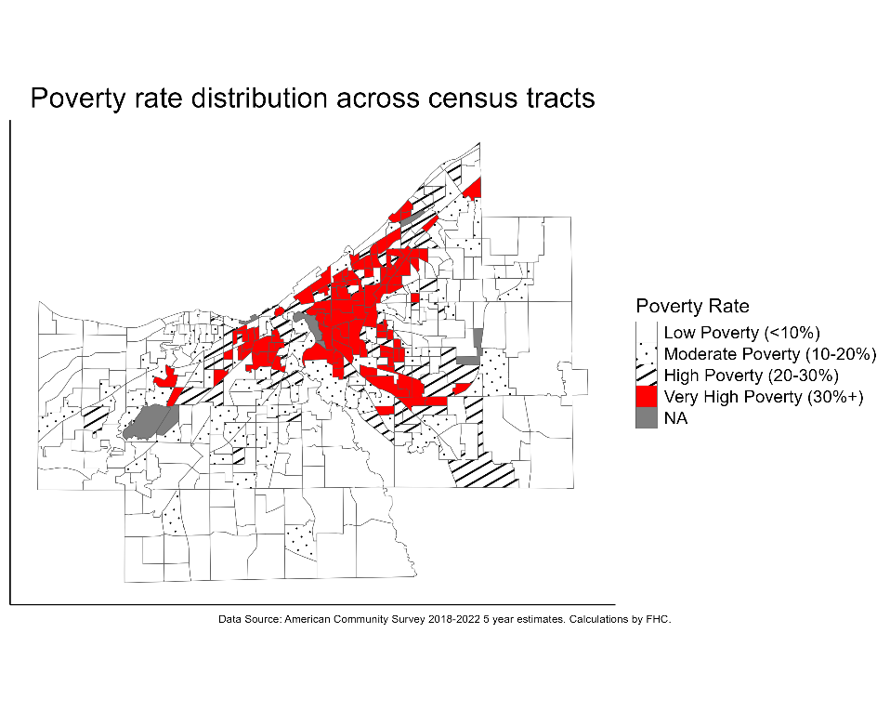
Both the poverty-rate and percentage non-white maps use a symbology in which the most disadvantaged areas are easily identifiable. Additionally, the single color and the other patterns allow the maps to be easily used by those with color blindness and vision impairments.
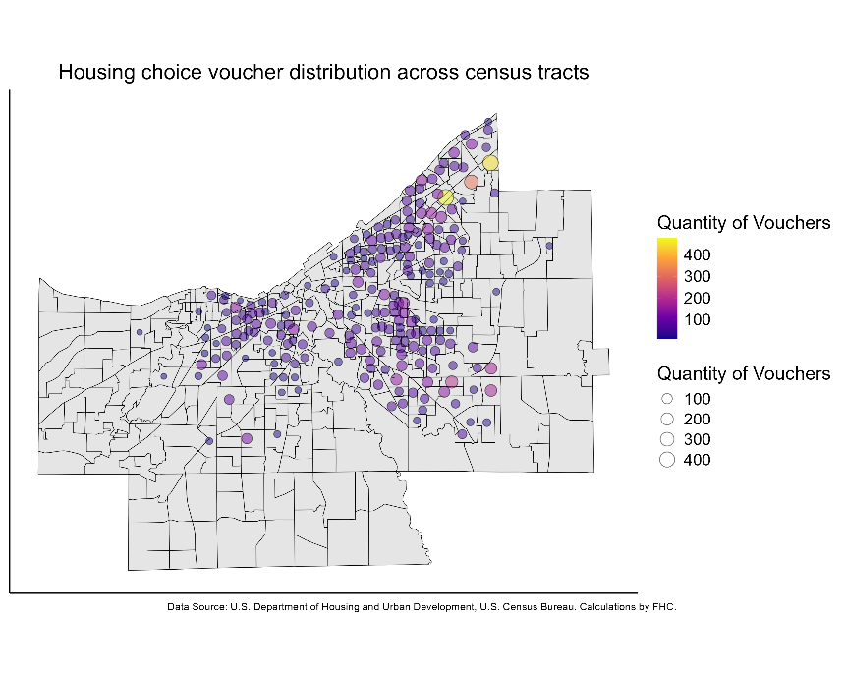
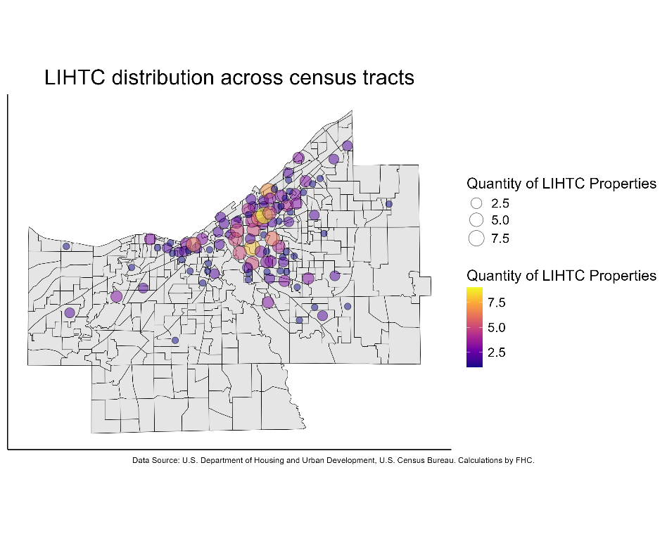
The LIHTC distribution and HCV distribution bubble maps identify areas by the quantity of the program implementation. Similar to the two previous maps, the largest quantities are present in the East Cleveland, Shaker Heights, and Cleveland Heights areas.
Percent Non-White | Number of LIHTC | Percent of Total LIHTC
0-20% | 12 | 4.98
20-50% | 45 | 18.67
50-80% | 45 | 18.67
80-100% | 139 | 57.68

Poverty Rate | Number of LIHTC | Percent of Total LIHTC
Low Poverty (<10%) | 7 | 2.90
Moderate Poverty (10-20%) | 45 | 18.67
High Poverty (20-30%) | 60 | 24.90
Very High Poverty (30%+) | 129 | 53.53

Percent Non-White | Number of HCV | Percent of Total HCV
0-20% | 207 | 1.45
20-50% | 2246 | 15.71
50-80% | 4843 | 33.88
80-100% | 6999 | 48.96
Aggregating the results at the county scale, both tables above show that more than fifty percent of the LIHTC properties are in areas that are either heavily segregated or very economically disadvantaged.

Poverty Rate | Number of HCV | Percent of Total HCV
Low Poverty (<10%) | 983 | 6.88
Moderate Poverty (10-20%) | 3208 | 22.44
High Poverty (20-30%) | 3866 | 27.04
Very High Poverty (30%+) | 6238 | 43.64

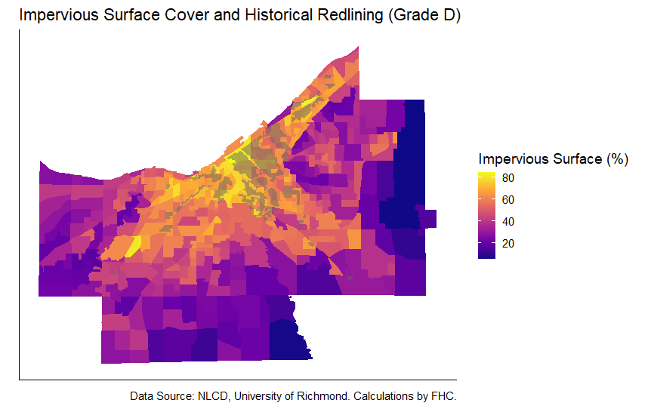
A similar case holds true for the usage of housing choice vouchers. Almost half of HCVs are used within areas heavily segregated while 43% of HCVs are used in areas of extreme poverty.
The above map details impervious surface cover with an overlay of historical redlining. To test the relationship between the percentage impervious surface cover and the number of LIHTC properties, a Pearson correlation test revealed a correlation coefficient of 0.32. This indicates a moderate positive linear relationship between impervious surface percentage and the number of LIHTC properties in a census tract. When performing the same test comparing the relationship between poverty rate and impervious surface cover there is a correlation coefficient of 0.60.
The results indicate a clear relationship in which highly segregated or extremely impoverished areas receive the most placements of LITHC properties and highest usage of HCVs. Policies should be promoting the usage and placement of these programs in areas with more opportunities for upward mobility compared to perpetuating areas of limited socioeconomic advancement. Many limitations exist when examining the relationship between landcover and subsidized housing. There are likely many other factors that contribute to differences in landcover outside of those two variables, however it still is helpful to know poverty is more highly correlated to impervious surface cover.
Throughout the process I learned the value of coding methodically. At the start of the project, I spent a lot of time attempting work before thinking about the process. Eventually, I was able to create a large function so that I could perform the bulk of my analysis across counties, but I wasted a lot of time attempting different processes before slowing down and thinking about how I can solve the problems.
Overall, this project highlights a need for careful planning of subsidized housing placement to promote greater movement of people of color and economically disadvantaged populations. Additionally, fair housing policies should be implemented such as sources of income protection to create increased access to affordable housing. This project further provides effective visuals and easy to understand statistics that could be shared to a wider audience, expanding awareness of HUD policies and fair housing.

References
Community Solutions Team. (2022, April 8). Measuring Racial Segregation in Cuyahoga County. The Center for Community Solutions. https://www.communitysolutions.com/resources/measuring-racial-segregation-cuyahoga-county
Housing Choice Voucher Tenants | HUD.gov / U.S. Department of Housing and Urban Development (HUD). (n.d.). https://www.hud.gov/helping-americans/housing-choice-vouchers-tenants
Low-Income Housing Tax Credit (LIHTC): Property and tenant level data | HUD USER. (n.d.). https://www.huduser.gov/portal/datasets/lihtc.html

